CASE STUDY 12 Attendance Recovery Computation
- Problem Statement
Calculate current attendance percentage and determine the minimum consecutive classes a student must attend to reach a required attendance percentage.
2. Objectives
Use arithmetic and conditional logic.
mApply a loop to find the minimum number of future classes needed.
Validate attendance inputs.
3. Assumptions
Required attendance is 75%.
Classes attended cannot exceed classes conducted.
The student attends every future class counted by the program.
4. Algorithm
1. Read classes conducted and classes attended.
2. Validate the values.
3. Calculate current attendance percentage.
4. If already at or above 75%, report that no recovery classes are needed.
5. Otherwise, increase a counter one class at a time until the projected percentage reaches 75%.
6. Display the result.
5. Flowchart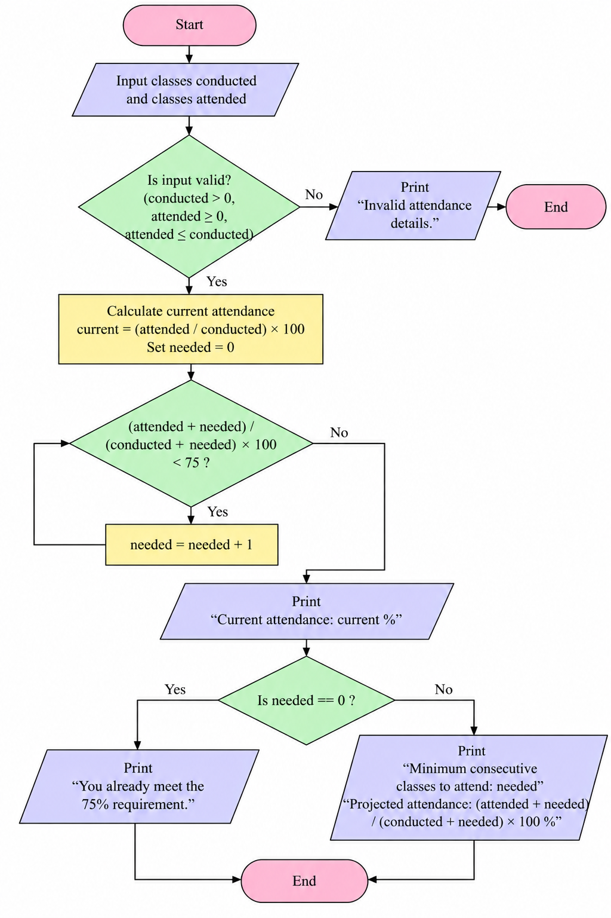
6. Pseudocode
START
INPUT conducted, attended
IF conducted <= 0 OR attended < 0 OR attended > conducted: PRINT invalid; STOP
current = attended / conducted * 100
needed = 0
WHILE (attended+needed)/(conducted+needed)*100 < 75: needed = needed + 1
PRINT current, needed
END
7. Test Cases
Test | Input / Scenario | Expected result
1 | conducted 40, attended 30 | Current 75.00%; 0 classes needed
2 | conducted 40, attended 20 | Current 50.00%; 40 classes needed; projected 75.00%
3 | conducted 0 | Invalid attendance details

8. Output Screenshot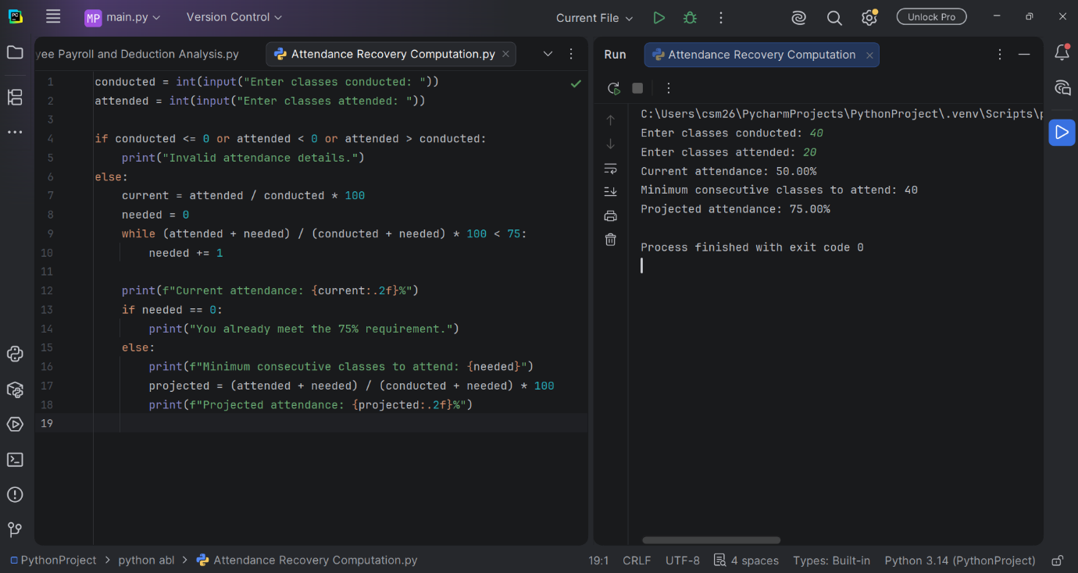
9. Conclusion
The loop finds the smallest number of future classes that must be attended to reach the required attendance percentage.

